Practical 5
    - SORTING
- Create the following worksheet and perform the following:

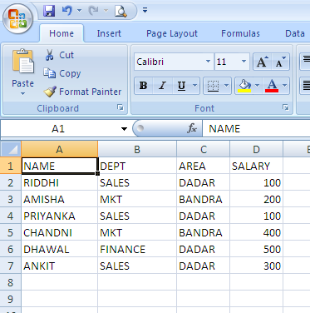
- Arrange the data in Alphabetical order of NAME.
- Arrange the data in Un-alphabetical (Z-A) order of NAME.
- Arrange the data in ascending order of SALARY.
- Arrange the data in descending order of SALARY.
- Arrange the data in Alphabetical order of DEPT and within DEPT ascending order of SALARY.
- Arrange the data in Alphabetical order of DEPT and within DEPT alphabetical order of NAME.

FILTER WITH CUSTOMIZED CONDITION

Create the following worksheet and answer the following:

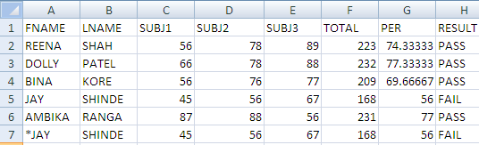
- To list only those records where FNAME starts with an alphabet “S”.
- To list only those records where LNAME ends with an alphabet “A”.
- To list only those records where LNAME has “N” as the second last character.
- To list only those records where LNAME has “I” as the second character.
- To list only those records where LNAME starts with an character “*”.
- To list only those records where RESULT is “PASS”.
- To list only those records where PER is more than 75 percent.
- To list only those records where PER is less than 75 percent.
- To list only those records where PER is >= 75% and <85%.
- To list first two records with highest percentage.

ADVANCED FILTER
Problem 1 Create a file name, basic salary & dept and to view only records for department sales.
Problem 2 Create a file name, basic salary & dept and to view only records for sales where salary is more than 2000
Problem 3 Create a file name, basic salary & dept and to view only records for sales, finance where salary is more than 2000

SUBTOTAL
- Answer the following in MS-EXCEL. Consider the following worksheet

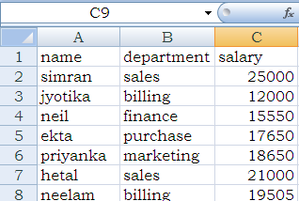
Write steps to obtain the department wise subtotals of the salary. Further explain the procedure to remove these subtotals from the worksheet.

- GRAPHICAL REPRESTATION OF DATA

- The following data has been entered in a worksheet
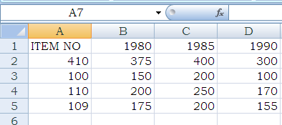
- To calculate the total in B6, C6 and D6
- To construct the 3-D Bar diagram
- To construct pie-chart diagram

- The following data has been entered in a worksheet
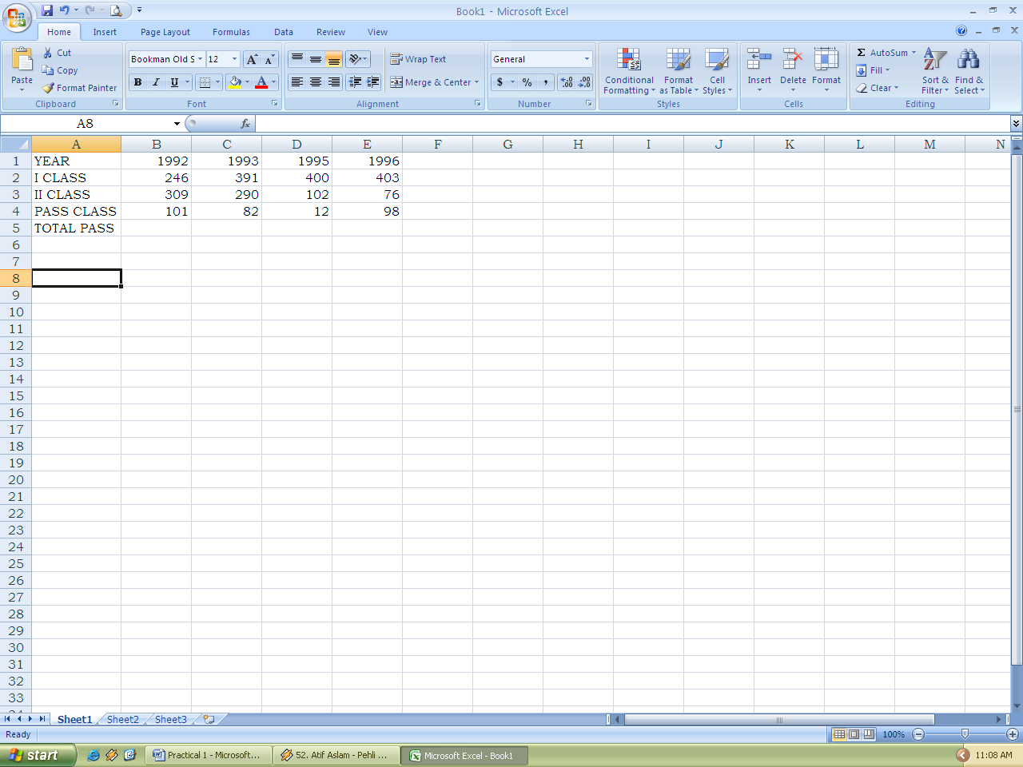
- To create a line diagram with base as years
- To represent the data with 3D bar diagram
- Pie diagram for the year 1993

- The following data has been entered in a worksheet
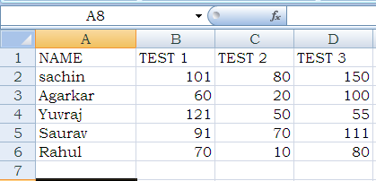
- Bar-chart
- Line chart
- Column chart

- The following data has been entered in a worksheet
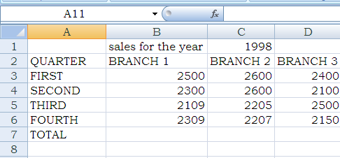
- To find the total sales of each branch
- To construct 3-D pie for total of each quarter
- To construct bar diagram for total of each branch

- The following data has been entered in a worksheet
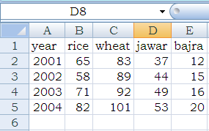
Based on these values, write steps
- To find the annual production in Column F
- To draw column chart of production of Rice and Wheat for 4 years
- To draw Pie chart for the production of year 2002.

- The sales figures for two depots have been entered in a worksheet in the following manner.
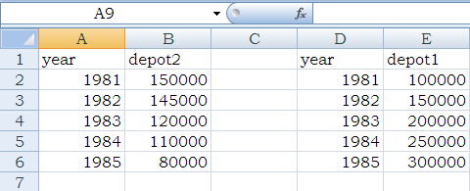
Write steps to construct the following charts to display year along X axis and sales of the two depots along Y axis
- a 3-D Bar chart with column series
- a line chart with the column series

PIVOT TABLE:
BUILDING PIVOT TABLE,
PIVOT TABLE REGION, REARRRANGING PIVOT TABLE

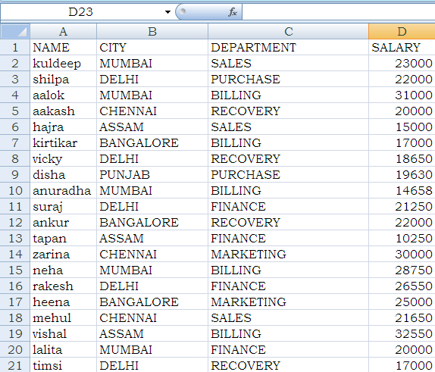
- What is Pivot table? Consider the following of employee details

Write the steps to prepare Pivot Table in cell A25 of the same worksheet, displaying CITY wise (1) average salary (2) maximum salary by taking CITY along row and SALARY in Data area
- The following data has been entered in a Ms-excel worksheet
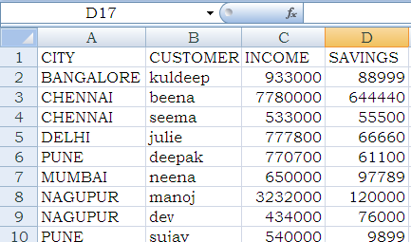

Write steps to set up a Pivot table at cell A20 of the same worksheet displaying CITY in row, customer in column, INCOME and SAVINGS as data items

